Problem 5:

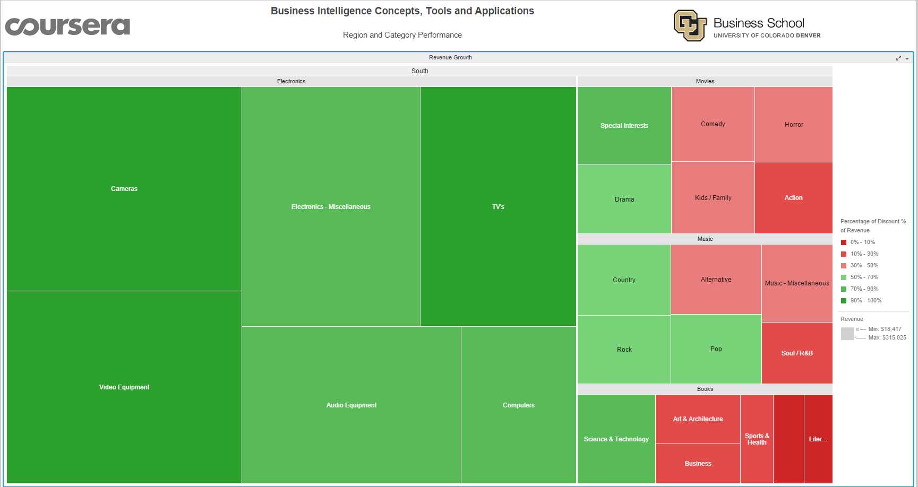

This is the snapshot of South.

The revenue of Computers is least, next is Audio Equipment followed by Electronics – Miscellaneous.